**Programming Assignment #4 – Account book of Minguinho**

Due date : 12/14 23:59:59

**<Introduction>**

Mr. M.kris, the owner of Market Minguinho, checks sales’ lists from a document and calculates the revenue for sold goods every day. The document is written about names, prices, sales number of sold goods and total sale prices every moment, which are in order as following:  
[Sales Document]  
….  
juice 500 6 3000  
coffee 600 2 1200  
coffee 600 9 5400  
….

**\*Be careful !!**The sales document could include invalid sales lists for price of a goods or total price of sold goods or both.

[Sales List and Price]  
1. pen: 800 won  
2. coffee: 1500 won  
3. bread: 2000 won  
4. juice: 1300 won

The purpose of the fourth assignment is making a sales settlement program for Mr. M.kris, which reads the sales document and prints the revenue after calculating the proceeds of the sales. If there are invalid sales lists in document, print the correct revenue and make new revised sales document to correct.

Two files will be given as an example. The file name "account_book_no_error.txt" is a normal file with no errors, and the "account_book_with_error.txt" is a file with errors.

**<Example & Result>**

**[Case #1: Print results of the Normal Document]**

**-**Use “account_book_with_error.txt” as input file and print it as following.

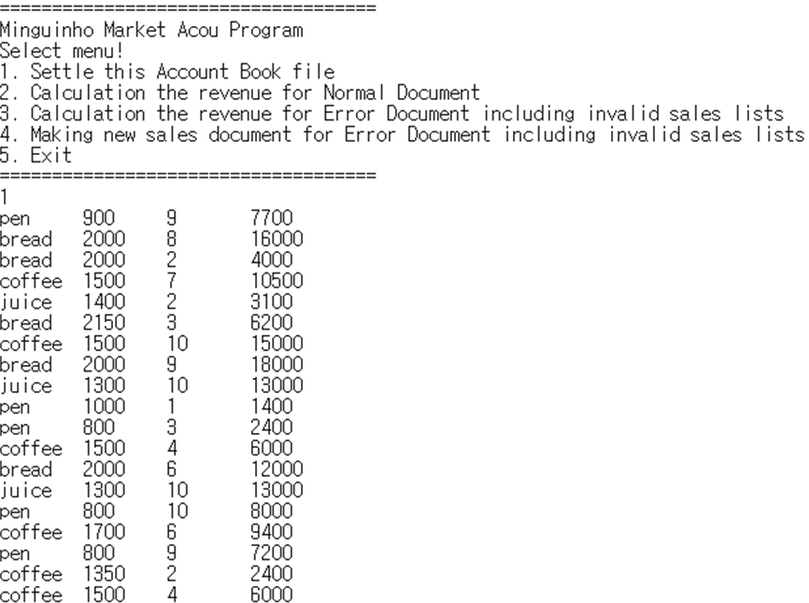

**[Case #2: Calculation the revenue for Normal Document]**

**-**Use “account_book_no_error.txt” as input file and print the total number & total price of each item sold & the revenue as following.

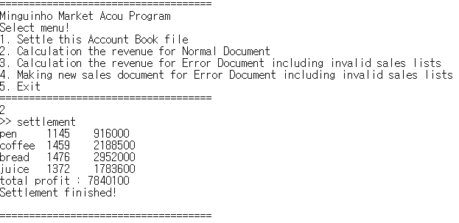

**[Case #3: Calculation the revenue for Error Document including invalid sales lists]**

**-**Use “account_book_with_error.txt” as input file, revise the incorrect contents and print the total number & total price of each item sold & the revenue as following.

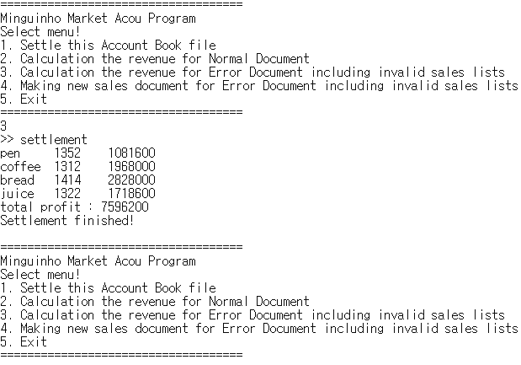

**[Case #4: Making new sales document for Error Document including invalid sales lists]**

**-**Use “account_book_with_error.txt” as input file, revise the incorrect contents and print the total number & total price of each item sold & the revenue as following. After then, make new sales document with revised values.

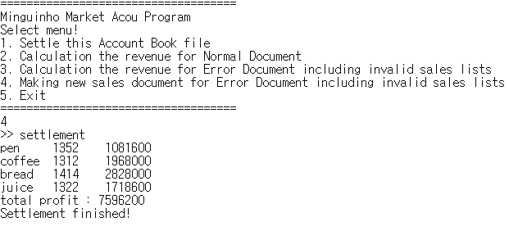

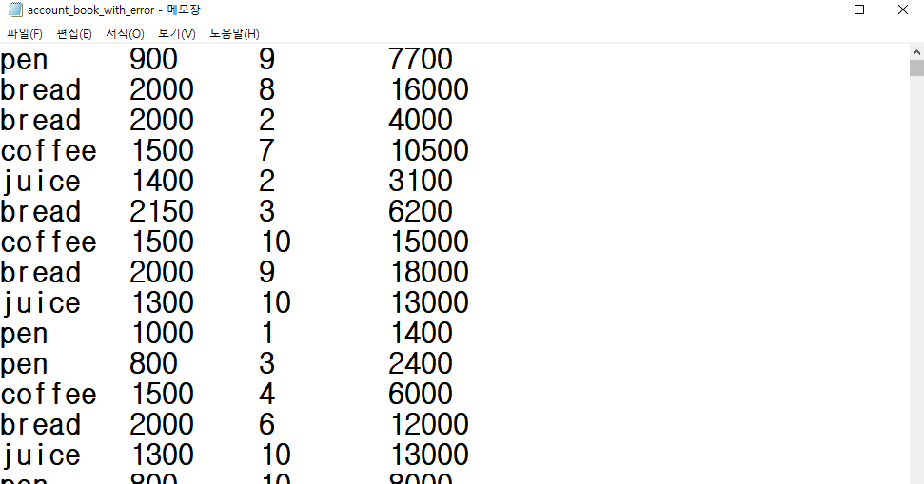 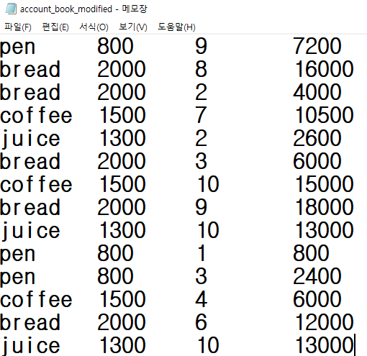

Before revision After revision

**<Rating>**

* Total point is 100 points (you should use fopen(), fread(), fgets(), fputs() functions).
* (#rating1) If program can read a given text file and print out the contents of that, you will get **20 points**.
* (#rating2) If you can settle the sales document (Normal, not including invalid entry), you will get **30 points**.
* (#rating3) If you can print the correct revenue after revision by using error documents, you will get **30 points.**
* (#rating4) If you can make new revised sale documents to correct, you will get **20 points.**
  + Delay penalty: 15 points deducted per day. After 3 days, **you will get 0 point**.
  + You should submit a source code file on i-campus. The source code should be compiled successfully. Otherwise, **you will get 0 point**.